University of Missouri

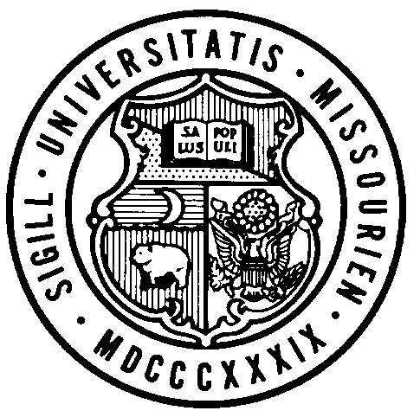
Board of Curators

Special Meeting

Wednesday, March 27, 2019
3:30 P.M.

Originating in 321 University Hall, Columbia, Missouri and at remote locations via conference telephone.

Public Session Dial-In Number: 888-606-4788
Conference Code: 822388#

AGENDA

PUBLIC SESSION – 3:30 P.M.

Call to Order – Chair Sundvold

Roll Call of the Board of Curators

General Business

Action
- Resolution for Executive Session of the Board of Curators Meeting

3:35 P.M. BOARD OF CURATORS MEETING – Executive Session
(or upon recess of the public session)

The Board of Curators will hold an executive session of the meeting on March 27, 2019 pursuant to Section 610.021(1), 610.021(3), 610.021(12) and 610.021(13) RSMo, for consideration of certain confidential or privileged communications with university counsel, personnel and contract items, all as authorized by law and upon approval by resolution of the Board of Curators.

